(Page of EODB)

**EASE OF DOING BUSINESS**

**INDUSTRIES AND COMMERCE DEPARTMENT, GOVT. OF ASSAM**

**(Or can directly go to the website of I& C, Govt. of Assam)**







**   **

**(Applicant will select Agency accordingly the agency page will be opened up where the registration link will be available)**

**( Link )**

**LAND BANK DETAILS**

**APPLICABLE RATES FOR ALLOTMENT OF LAND/ SHED AT DIFFERENT LOCATIONS**

* **ASSAM INDUSTRIAL DEVELOPMENT CORPORATION LTD. (AIDC)**
* **ASSAM INDUSTRIAL INFRASTRUCTURE DEVELOPMENT CORPORATION (AIIDC) LTD.**
* **ASSAM SMALL INDUSTRIAL DEVELOPMENT CORPORATION LTD. (ASIDC)**
* **......................**
* **......................**

**\* (Applicant can view applicable rates of land by visiting respective Corporations)**

**STANDARD OPERATING PROCEDURE FOR ALLOTMENT OF LAND / SHED**

**LAND MANAGEMENT RULE FOR INDUSTRIAL AREAS**

**FORMAT OF LEASE AGREEMENT**

* **ASSAM INDUSTRIAL DEVELOPMENT CORPORATION LTD. (AIDC)**
* **ASSAM INDUSTRIAL INFRASTRUCTURE DEVELOPMENT CORPORATION (AIIDC) LTD.**
* **ASSAM SMALL INDUSTRIAL DEVELOPMENT CORPORATION LTD. (ASIDC)**
* **......................**

**(Next page)**

REGISTRATION (For New User)

LOGIN (For Existing User)

**APPLICANT USER REGISTRATION**

Note: * Indicates mandatory fields

|  |  |  |
| --- | --- | --- |
| * First Name | (Mr./ Mrs./ Ms.) | (Enter First Name) |
| Middle name | (Enter Middle Name) | |
| * Last Name | (Enter Last Name) | |
| * Name of Company / Firm |  | |
| *Address of registered office |  | |
| Land Line Number |  | |
| * Mobile Number |  | (For Receiving SMS) |
| * Email ID |  | (For Receiving Emails) |
| * User ID |  | |
| * Password |  | (Password length should contain minimum 6 letters with at least 1 upper case letter and 1 numeric) |
| * Confirm Password |  | |

Reset

Submit

* (After submission of Applicant User Registration, a registration number will be auto generated which will be sent to registered mobile number and email id provided by the applicant which should be used for further submission of application form after Login)

Password

APPLICANT LOGIN



If you have not yet registered with us then please [**click here**](http://117.239.80.70/gidcgg/user-registration.aspx) for new Registration

Forgot Password?



Reset

Login

Time: (Reflected automatically)

Date: (-do-)

Welcome................................................

|  |  |  |  |  |  |
| --- | --- | --- | --- | --- | --- |
| **Application Form** | Details of Company/ Firm | Upload Documents | Self Declaration | Payment | Letter of Acknowledgement |

Note: All fields are mandatory

|  |  |  |  |  |  |  |
| --- | --- | --- | --- | --- | --- | --- |
| Name of the Company/ Firm | (Automatically reflected after registration) | | | | | |
| Address of registered office | (Automatically reflected after registration) | | | | | |
| Mobile Number | (Automatically reflected after registration) | | | | | |
| Name of Agency | (Automatically reflected) | | | | | |
| **Name of Industrial Estate/Industrial Area/etc. where shed/Land is required**  (Applicant should select whichever is applicable) | * IIDC Nalbari * IIDC Malinibeel * IIDC Naltali/ Bhomoraguri * IIDC Dalgaon * IIDC Demow * IIDC Silapathar For the case of AIDC. * IIDC Titabor * EPIP * IGC Balipara * IGC Matia | | | | | |
| **Requirement of Space for**  **(in Sqm.)** | Open | | | Covered | | |
| Nature of proposed Industry | (Whether engineering/Chemical/Textile/Leather/Glass/Plastic etc) | | | | | |
| Built up Area/ Covered Area |  | | | | | |
| Proposed utilization for Production Shed |  | | | | | |
| Proposed utilization for Godown |  | | | | | |
| Proposed utilization for Office |  | | | | | |
| Any other details |  | | | | | |
| Total Project Cost |  | | | | | |
| Means of Finance |  | | | | | |
| **Proposed investment in** | **Plant & Machinery** | | | | **Working Capital** | |
| **Proposed list of Machinery & equipment** | Item & Specification   * ...... * ....... | HP/KE Rating of Motors   * ...... * ....... | | | Price (Approximate)   * ...... * ....... | |
| Debt Service Coverage ratio |  | | | | | |
| Internal Rate of Return |  | | | | | |
| Payback Periods |  | | | | | |
| Name of Product to be manufactured |  | | | | | |
| Installed Capacity |  | | | | | |
| **Proposed annual consumption of Major Raw Materials:** | **Item & Specification**   * ...... * ....... | | **Quantity**   * ...... * ...... | | | **Approximate Value**   * ...... * ....... |
| Proposed Production Capacity/ day |  | | | | | |
| Number of Shift |  | | | | | |
| No. of Workers to be Engaged |  | | | | | |
| Proposed Export |  | | | | | |
| Expected Date of Construction |  | | | | | |
| Expected Date of Production |  | | | | | |
| Category of Unit  (Applicant should select whichever is applicable) | * Micro * Small * Medium * Large | | | | | |
| Special category, if any  (Supporting Document to be attached with Project Profile) | * General/ OBC * SC/ ST * Physically Handicapped * Women Entrepreneur | | | | | |
| Power Requirement (in KW) |  | | | | | |
| **Consumption electrical units per month** |  | | | | | |
| **Proposed requirement of Water/day** (in KL) |  | | | | | |
| Effluent Problem, if any  (Applicant should select whichever is applicable) | * Yes * No | | | | | |
| **Effective steps taken to start the unit** | * ...... * ...... | | | | | |

Submit

Save

Time: (Reflected automatically)

Date: (-do-)

Welcome................................................

|  |  |  |  |  |  |
| --- | --- | --- | --- | --- | --- |
| Application Form | **Details of Company/ Firm** | Upload Documents | Self Declaration | Payment | Letter of Acknowledgement |

Note: All fields are mandatory

|  |  |  |  |  |  |  |
| --- | --- | --- | --- | --- | --- | --- |
| Constitution of the Company/ Firm  (Applicant should select whichever is applicable) | * Proprietorship Firm/ * Partnership Firm/ * Private Ltd. Company/ * Public Ltd. Company | | | | | |
| Details of Registration/ Entrepreneurship Memorandum Incorporation of Firm/ Company |  | | | | | |
| PAN of Firm/ Company  (Mandatory for Private/ Public Ltd. Company) |  | | | | | |
| Category of Firm/ Company |  | | | | | |
| * Proprietorship Firm   (If the applicant has selected proprietorship firm) | (Name of Proprietor) | | | (PAN/ ADHAAR) | | |
|  | | |  | | |
| (Add row if required) | | | | | |
| * Partnership Firm   (If the applicant has selected proprietorship firm) | (Name of Promoter/ Director ) | (PAN/ ADHAAR) | Phone No. | | Email Id | Shares |
| (Name of Promoter/ Director ) | (PAN/ ADHAAR) | Phone No. | | Email Id | Shares |
| (Add row if required) | | | | | |
| * Private Ltd. Company   (If the applicant has selected proprietorship firm) | (Name of Promoter/ Director ) | (PAN/ ADHAAR) | Phone No. | | Email Id | Shares |
| (Name of Promoter/ Director ) | (PAN/ ADHAAR) | Phone No. | | Email Id | Shares |
| (Add row if required) | | | | | |
| * Public Ltd. Company | (Name of President/ Vice President/ Director) | | | (PAN of Company) | | |
| * Background of Promoters/ Directors | On academic lines | | | On professional lines  (Add row if required) | | |

Submit

Save

Time: (Reflected automatically)

Date: (-do-)

Welcome................................................

|  |  |  |  |  |  |
| --- | --- | --- | --- | --- | --- |
| Application Form | Details of Company/ Firm | **Upload Documents** | Self Declaration | Payment | Letter of Acknowledgement |

* All the pages of the documents to be uploaded should be signed by the authorised signatory. The authorisation letter should be attached.

|  |  |
| --- | --- |
| PAN Card and Photo ID Proof | (Upload Document) |
| Address Proof of the Applicant | (Upload Document) |
| Techno Economic Feasibility Report/ Project profile | (Upload Document) |
| Appraisal by Bank/ Financial Institution for availing financial assistance | (Upload Document) |
| Plant layout indication the area for installation of machinery/ Space for raw material/ finished products/ generator shed/ utility service etc. | (Upload Document) |
| Last three years Balance Sheet of Enterprise in case of existing Unit | (Upload Document) |
| Solvency Certificate from Bank/ Financial Institution in case of new unit | (Upload Document) |
| Any other relevant document | (Upload Document) |

Submit

Save

* (All documents to be uploaded in PDF format)

Time: (Reflected automatically)

Date: (-do-)

Welcome................................................

|  |  |  |  |  |  |
| --- | --- | --- | --- | --- | --- |
| Application Form | Details of Company/ Firm | Upload Documents | **Self Declaration** | Payment | Letter of Acknowledgement |

To

The Managing Director,

AIDC Ltd. / AIIDC Ltd. / ASIDC Ltd.

Sir,

1. I/We have read the Rules & Conditions of allotment in Industrial Areas of AIDC/ AIIDC/ ASIDC together with the forms thereof.
2. I/We, the undersigned, hereby offer to take on 30 (thirty) years Lease the Plot of land measuring as stated on the terms and conditions set out in the **AIDC/ AIIDC/ ASIDC Land Management Rules** and offer to enter into Lease Agreement (approved by Govt. of Assam) with you in respect of the said Plot.
3. The Lease will commence from the date from which the allotment of the Plot is made to me/us and the obligations and liabilities under the Lease Agreement will be deemed to have commenced from that date.
4. I/We have filled up the Online Application form giving necessary information in respect of my/our industry.
5. I/We hereby agree to pay the Ground Rent and Service Charges fixed by the Corporation **within 90 (Ninety) days from** the date of Allotment Letter and the Ground Rent and Service Charges as revised by the Corporation from time to time every year in advance, before the 30th April and 31st July respectively of that year.
6. **Payment:**

I/We hereby agree to pay necessary payments towards amount of Security Deposit and 10% amount of Development Charges (Security Deposit calculated @ of Rs.5.00/- per Sq. mtrs. or part thereof and Processing Fee of 1% of the total value of land) in favour of concerned agency for the performance of the terms and conditions herein.

1. I/We understand that no interest will be payable on the amount of Security Deposit and 10% Development Charges.
2. Should I/We fail to execute and complete the Lease Agreement within 1 (one) week from the date of allotment letter or within such extended period as you may permit, the Corporation will be at liberty to forfeit the Security Deposit, cancel the allotment of Plot without prejudice to all other rights of the Corporation.
3. I/We assure that no pollution/effluent in any form (solid, liquid, gas) shall be emitted from my/our allotted Plot and if I/we do not observe this prohibition then Corporation shall be at liberty to take over the demised premises with all assets therein and cancel the allotment of the Plot without prejudice to all other rights of the Corporation.
4. I/We also agree to the effect that the Corporation shall be at liberty to dispose of the taken over assets by way the Corporation understands suitable and I/We shall accept the sale proceeds after reducing all type of expenditure incurred and penalties imposed by the Corporation if any, from the amount realized on disposal of assets.
5. I/We hereby agree to pay the Special Maintenance Charges fixed or revised by the Corporation from time to time any other charges levied by the Govt. in addition to Ground Rent and Service Charges.
6. I/We shall pay all costs, charges and expenses of the Corporation and incidental to the preparation, execution and completion to the Land Lease Agreement and of the lease, including costs of all correspondence with you or otherwise, Stamp Duty, Registration Charges and other outgoing and costs of supplying one additional Copy to the Corporation.
7. The Managing Director, AIDC/ AIIDC/ ASIDC or any other Officer authorized by the Corporation will be acting on its behalf for the purpose of this Application and its acceptance and for all purpose(s) connected with the preparation and execution of the Land Lease Agreement.
8. Any Notice, Letter or Communication or Intimation addressed to me/us at the following address will be deemed as valid for all purposes.
9. I am/we are willing to accept any Plot which is allotted to us by the Corporation. However, if the Area applied for by me/us is changed, I/We have the option to reject the offer within a week from the date of issue of Allotment Letter.
10. I/ we do hereby accept that, I/ we will deposit further balance amount as per the Land Allotment rule, if my/ our online application is accepted by the Land Allotment Committee.

**Declaration:** I/ We have read and accepted all the terms and conditions as stated above and agree to pay the necessary amount for my application of land.

Agree and Submit

Time: (Reflected automatically)

Date: (-do-)

Welcome................................................

|  |  |  |  |  |  |
| --- | --- | --- | --- | --- | --- |
| Application Form | Details of Company/ Firm | Upload Documents | Self Declaration | **Payment** | Letter of Acknowledgement |

|  |  |
| --- | --- |
| Name of Agency | (Automatically Reflected) |
| Name of Firm/ Company | (Automatically Reflected) |
| Phone Number | (Automatically Reflected) |
| Registration Number | (Automatically Reflected) |
| Land Requirement | (Automatically Reflected) |
| Amount |  |
| * 10 % of total Development Charges | (Automatically calculated by the system ) |
| * Security Deposit: Rs. 5.00 per Sqm. | (Automatically calculated by the system ) |
| * Processing Fees of 1 % on total value of land |  |

Total Amount to be paid: Rs. (Automatically Calculated)

Cancel

Pay

Payment Gateway

(*A new page for payment will be open up)

Time: (Reflected automatically)

Date: (-do-)

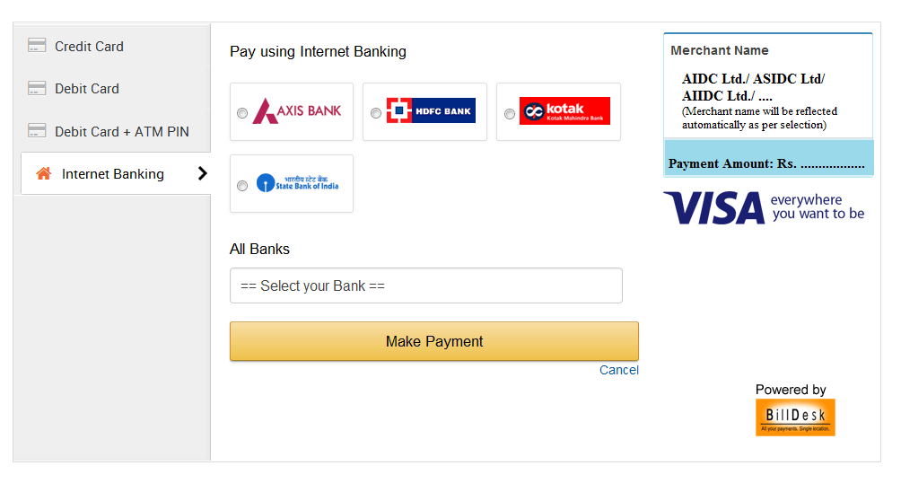

Auto generated Payment Receipt

|  |  |
| --- | --- |
| Name of Agency | (Automatically Reflected) |
| Name of Firm/ Company | (Automatically Reflected) |
| Phone Number | (Automatically Reflected) |
| Registration Number | (Automatically Reflected) |
| Land Requirement | (Automatically Reflected) |
| Paid Amount | (Automatically Reflected) |
| Transaction ID | (Automatically Reflected) |
| Transaction Time | (Automatically Reflected) |
| Date | (Automatically Reflected) |

Print

Time: (Reflected automatically)

Date: (-do-)

|  |  |  |  |  |  |
| --- | --- | --- | --- | --- | --- |
| Application Form | Details of Company/ Firm | Upload Documents | Self Declaration | Payment | **Letter of Acknowledgement** |

Dear............................,

Print

We hereby acknowledge the receipt of your Application of land measuring ........................ Sqm. at .................................... along with payment of Rs. ...........................................

Your application will be further examine by the Department for Allotment of Land.

Thanks and Regards

AIDC/ ASIDC/ AIIDC (Concerned agency automatically reflected)

(This is system generated statement hence does not require signature)

Print